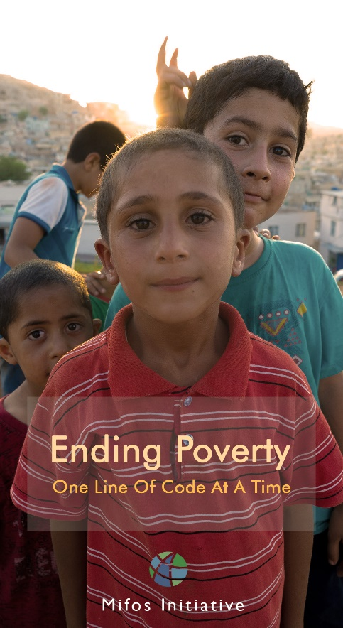

My experience at Google Code-In 2017, With the Mifos Initiative (Mid-Way)

Written by: who wrote this (?). (luphieanza)

Peace be upon you, and Allah mercy and blessings

For before, I would like to say first to my fellow GCI compatriots as well as to all parts of the Google Code-in and Mifos Initiative, saying "HAPPY NEW YEAR 2018".

And sorry if many words of regional accent because this blog post is only modest to be read by fun by humans equally :v

Introduction

First of all I will explain a bit of my identity (for those of you who do not know me): v  
Introduce, my name is Muhammad Rafly Andrianza I come from Jakarta, Indonesia and studying at SMKN 2 JAKARTA in the Majors of Software Engineering, sitting in 11th grade and 16 years old. And this is my contact number +62 877 8037 4765 (little promotion) :v

**An explanation of Google Code-in and Mifos Initiative :**

Google Code-in

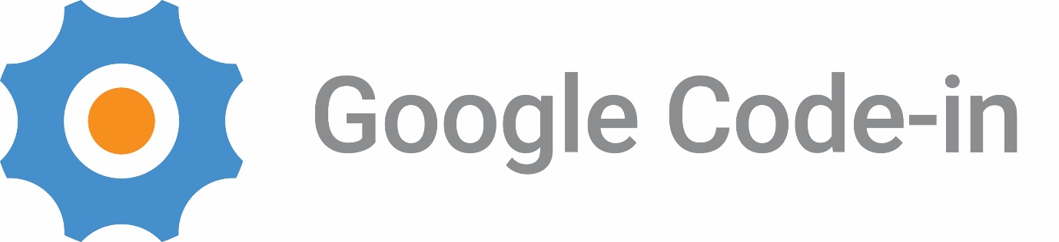

What is that ? google code-in? yes, from the name alone we already know that it is a related to "Google" company that is famous in this world to the extent that I fall in love with dozens of their products are very helpful to humans <3, then there is the name GCI, is a contest event to introduce pre-university participants who are 13-17 years old know the name "Open Source" well, open source itself is a word related to "freedom" in the sense of me Open Source is a system of any development that is OPEN here we can edit , create, duplicate, etcetera a system of development but remember even though it is open there is still its license also from the owner of a development system, hence honor the patent there ya 😉.  
Back again, to the word "GCI" I explained about GCI now I will give again about GCI a little deeper: D. At GCI we solve a problem with the processes and results that exist in opensource organizations selected by google to work on, the tasks they provide vary, from encoding, user interface, research, documentation, and system quality checks.

I know GCI from the gaze of career.google.com site do you know? That is a job site on google. WOW. Yep is right, I am eager to work on google. Hehe: p there I found their program and that's GCI at that time I do not know clearly what this is.  
Yes because the GCI program is already running I just follow the program because of its annual nature, (let me know the direction more clearly) whehehe.  
I joined GCI 2016 and at that time I really did not understand and just completed 3 easy tasks from them (yeayy can certificate: p)  
And a year has passed I tried to re-join this google program on GCI 2017 until now, thank God I am in the top board of the organization Mifos Initiative. Why that mifos initiative what else? (for the first time, below explanation what is mifos) let's continue my exploration of this; D.

Mifos Initiative

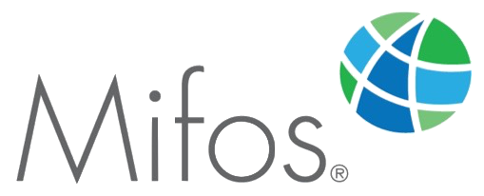

What is Mifos Initiative? here I will explain about mifos, is an open source organization that focuses on financial inclusion, vision of their mission is great. They want to eradicate poverty in this world through digital. Like their bold motto "Ending Poverty One Line Of Code At A Time". Well, that's where I chose this organization because of their mission vision is very big and one more thing, this organization is related to financial technology (fintech) which will be very helpful knowledge that I get at mifos initiative for later use of this my experience, when I practice internship at PT .Bank Central Asia, tbk (not a promotion,yeah) in early February, 2018.  
Being in this organization makes me confident that even the smallest contribution from me and other GCI participants can help 2 billion poor people in this world.  
Another thing that makes me proud is their team is small but can deliver service to the whole world, Awesomee (great right!).

My Experience

Well this is what the audience eagerly awaited: v  
Previously thanks to all of you who still accompany me by reading the blog post until right now: D (thank you very very…) wheheh.  
At that time I was late to register and started to participate when I entered the second week of GCI2017, because the first week I was following Hackathon DKI Jakarta, after which I started doing the tasks assigned by Mifos Initiative. Alhamdullilah, until now I have completed 19 tasks.

Good Week and Bad Week for Me

in the 3rd and 4th weeks is a difficult week for me, by that time the tasks in the Mifos organization have been exhausted and have only been left to tasks that I do not understand, as I understand that there is a strategic role to produce a good fruitful contribution. Then I focus on the quality of the task I do rather than the quantity of tasks (but this is important too). Week 4 passes, then continued with a good week of 5th and 6th week of the week I have understood how important an active role in the community and helping other difficult participants. Lots of experiences I've gotten this week from learning together, helping each other, being active with the community and mentors.

Plan ahead of Me

As for my future plans until the final blogpost is made again, is to able completed the task at least 35+ high quality, yes even now only 19. No one will know about the future, pray to the Allah and try harder and harder. And if possible I hope to be a winner of this GCI contest in the organization Mifos Initiative and bring the good name of INDONESIA to the international scene!

The closing of this, apologize for the many mistakes of the word (so many: v)

Due to this blogpost destined my peers and my beloved family, pray and support me to continue to be a winner and can bring our good name as WARGA INDONESIA.

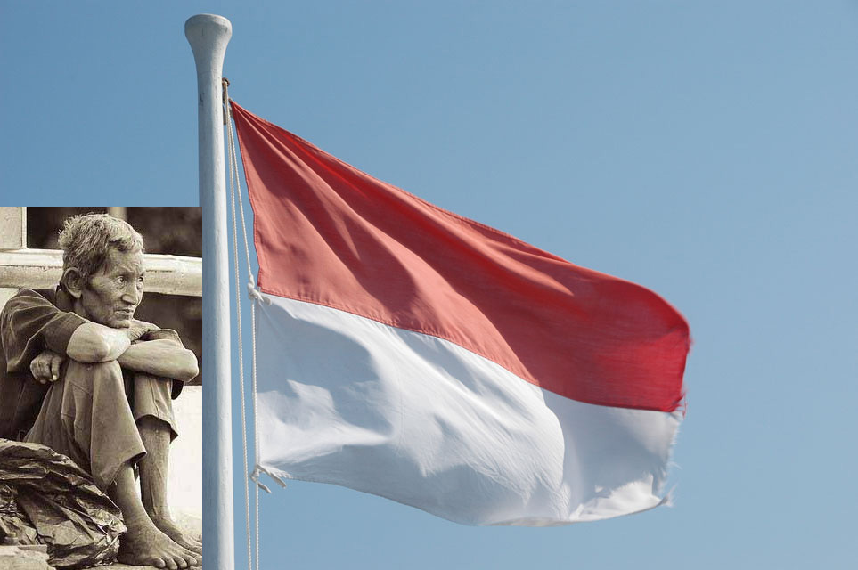

Wassalamualaikum, Wr.Wb

Muhammad Rafly Andrianza

-luphieanza-

GCI 2017 Participant

